MiniStiMo: A Solution for Chronic, Wireless DBS in Small Animals

1st William Nacci
Electrical and Computer Engineering Rice University
Houston, TX, USA wn15@rice.edu
2nd Yuhui Li Biomedical Engineering Duke University Durham, NC, USA yuhui.li@duke.edu
3rd Maria Velasquez Electrical Engineering Pontifica Univ Javeriana Bogota, Columbia
marialvelasquez@javeriana.edu.co
4th Rohit Satish Biomedical Engineering Johns Hopkins University Baltimore, MD, USA rsatish2@jh.edu

5th Jacob T. Robinson
Electrical and Computer Engineering Rice University
Houston, TX, USA jtrobinson@rice.edu
6th Warren M. Grill Biomedical Engineering Duke University Durham, NC, USA warren.grill@duke.edu

6th Caleb Kemere
Electrical and Computer Engineering Rice University
Houston, TX, USA caleb.kemere@rice.edu

Abstract—Deep-brain stimulation (DBS) in small-animal models is an indispensable tool for pre-clinical evaluation of neuromodulation therapies, yet most existing stimulators are limited by tethers, short operating life, or high cost. Additionally, for such devices to make a significant impact on the field, there is an increasing need for improved documentation and accessibility, enabling practical reproducibility at scale. Here we report the Miniturized Stimulation Module (MiniStiMo), a fully open-source, low-cost, and compact, low bill of materials (low- BOM) wireless neural stimulator that can provide controllable stimulation for up to four weeks on a single primary cell while providing Bluetooth Low Energy (BLE) command capability. The head-mounted device integrates a battery, BLE microcontroller unit (MCU), and a sensor, with average power consumption below 1mW during constant biphasic stimulation. Device efficacy was evaluated in a unilateral 6-hydroxydopamine Parkinsonian rat model.
Index Terms—DBS, small-animal, stimulator, low-cost

- Introduction
Small animal DBS studies focusing on the chronic effects of therapeutic stimulation are often limited by the practical constraints of the available stimulator systems. Many experiments require practical and scalable approaches to implement configurable stimulation systems, but the limited availability of wireless DBS systems that meet these needs remains a significant barrier [1] [2] [3] [4]. While prior work has demonstrated systems capable of long-term stimulation, many rely on custom hardware, complex manufacturing or implantation steps, or do not have distributable schematics and designs, limiting their utility to the broader field [5] [6] [2]. Robust and comprehensive materials to support reproducibility and adoption are also often absent, reducing the ability of devices to be used and implemented by other groups [7]. With these considerations in mind, the MiniStiMo was developed, a low-BOM, long-term, and open-source fully wireless stimulator for small animals.
NINDS R01NS115233, R56NS117549, NIMH R01MH139216.
- Methods
- System Architecture
The MiniStiMo uses a minimal hardware platform with only a single microcontroller unit (MCU; Infineon CYBC4247) boost converter (Maxim Integrated MAX1724), and supporting passive components. The MCU contains a radio configured for Bluetooth Low Energy (BLE), and the inclusion of a small antenna (Johanson Technology Inc. 2450AT42B0100001E) enables support of bidirectional communication with many consumer electronics. The BLE MCU also integrates a current digital-to-analog converter (IDAC) on chip, eliminating the need for an external stimulation circuit and supporting hardware. The standalone stimulator board measures 30 mm in diameter and 2.7 mm in height. When including the battery board, the MiniStiMo stands at 16 mm tall. Manufacturing and assembly were provided by a fabrication house (PCBWay) for
$31.22 per board. The MiniStiMo stimulator weighs 3.6 g with just the standalone stimulator board, 10.5 g with battery board and battery, and 19.5 g including battery, battery board, and housing.
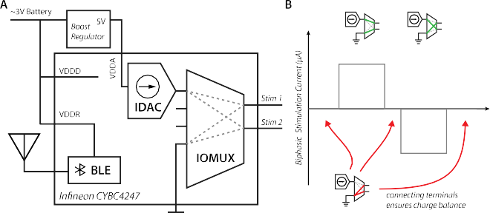



Fig. 1. (A) System diagram. (B) The MiniStiMo charge balances the current digital to analog converter (IDAC) via grounding with the built in input-output multiplexer (IOMUX).

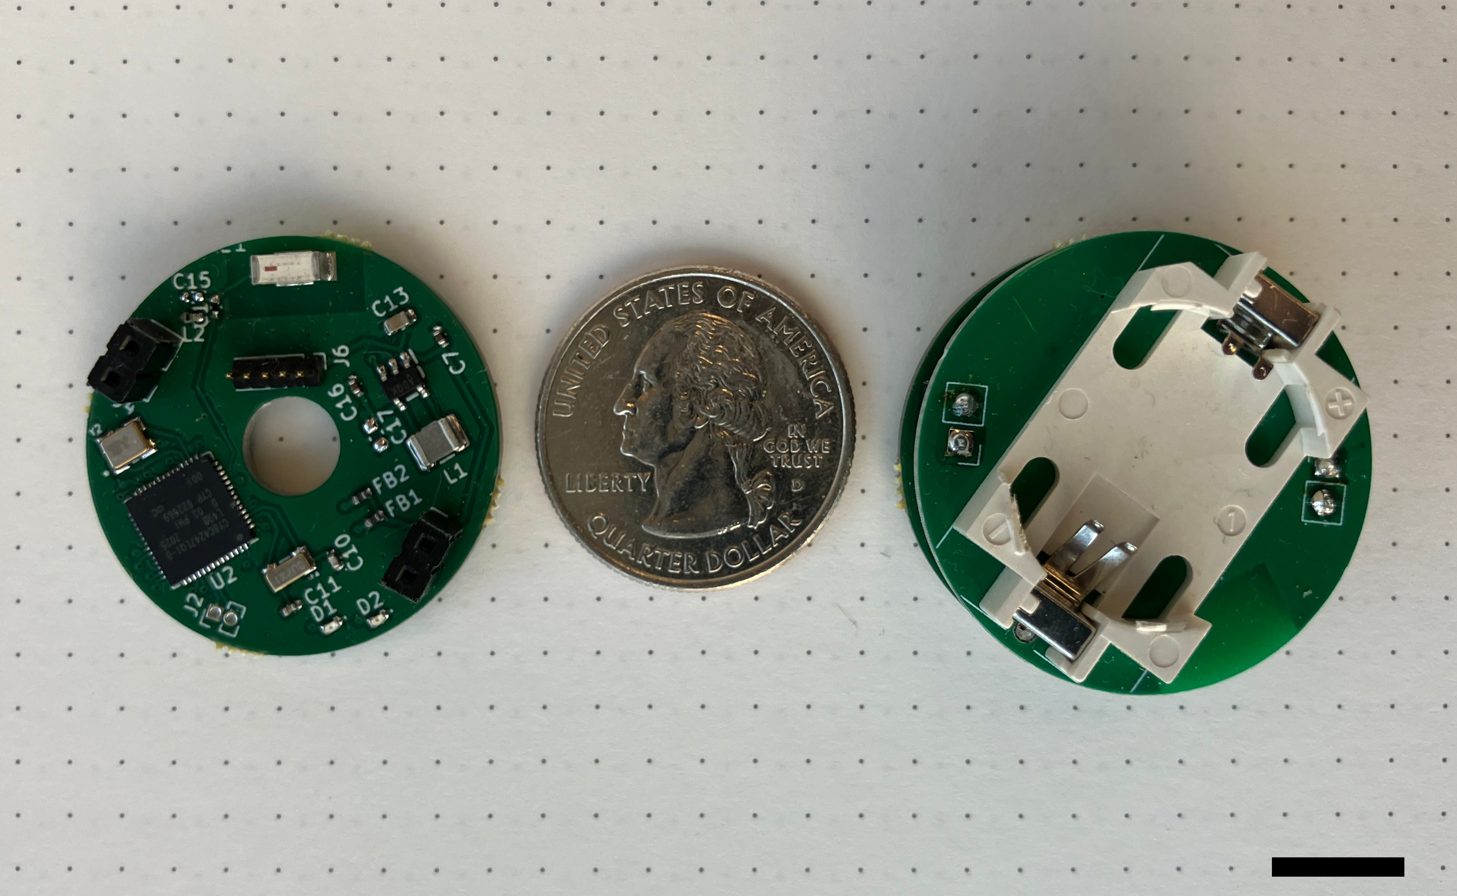

Fig. 2. Assembled MiniStiMo devices. Scale bar, 1 cm.

- Current-Controlled Stimulator
The onboard IDAC of the BLE MCU is powered by an external 5 V boost regulator connected to the CR2032 battery, and is configured to be capable of outputting 0-240 uA of stimulation current at 1-200 Hz, with a set pulse width of 60 µs. As shown in Fig. 1, the stimulator balances charge at every stimulation pulse via a grounding scheme before, during, and after stimulation pulses. This configuration is controllable via the BLE link and configuration details can be read wirelessly upon connection.
- Characterization methods
To ensure accuracy between the set stimulation current and the device output current, a 5.1 kΩ resistor (Vishay) was connected to the stimulator. Stimulation current was varied from 40 µA to 240 µA in approximately 20 µA intervals at a stimulation frequency of 130 Hz. The voltage across the resistor was measured and converted to current based on the measured resistance with a multimeter (FLUKE 73 Series 3). This protocol was repeated with a 10 kΩ resistor (Vishay) to gauge system compliance thresholds.
To validate performance in an environment more similar to neural tissue, further stimulation tests were performed within a phosphate-buffered saline (PBS, Research Products International) solution. A platinum-iridium stereotrode (MicroProbes, 10 kΩ at 1 kHz) was connected to the stimulator and immersed in the PBS solution. Stimulation output was then varied from 40 µA to 240 µA in approximately 20 µA intervals with stimulation frequency held constant at 130 Hz. Voltage across the electrode was recorded throughout each of these stimulation amplitude intervals.
Finally, the capacitive response was determined using the same stereotrode submerged in PBS with a 1 kΩ resistor connected in series. Voltage readings were taken across the resistor and converted to current using the measured resistor value.
To measure power consumption, a power profiler (Otii Arc Pro, Qoitech) was connected to the battery terminals of the MiniStiMo during stimulation through the PBS solution.
Power consumption was measured at 3 V, the nominal voltage of most high-capacity lithium CR2032 batteries, and recorded using the Otii software kit.
- Software and Firmware
The BLE MCU is programmed with the attached header pins on the device using the firmware available in the MiniStiMo GitHub repository.
Wireless control of the MiniStiMo is enabled by an IOS App. This app is able to read advertising devices in the vicinity and connect to any of them to read and alter stimulation settings. Once connected, the device’s time since starting, stimulation frequency, and stimulation amplitude are read. Stimulation amplitude and frequency are able to be set from 0-240 µA and 1-200 Hz, respectively.
- In Vivo Validation Methods
Two female Sprague Dawley rats (weight 300-330 g, 90-120 days old) were used in the in vivo validation study. All animal care and experimental procedures were approved by the Duke University Institutional Animal Care and Use Committee.
Animal surgery and procedure were similar to those previously described [8]. Under anesthesia with sevoflurane (induced at 7% and maintained at 3.25%), the animals were fixed in a stereotactic frame. The body temperature was maintained at 37 ºC. Meloxicam (2.0 mg/kg, s.q.) and Bupivacaine (0.2 mL of 0.25%, s.q.) were administered for analgesia. Dexamethasone (0.5 mg/kg, s.q.) was administered to reduce cerebral edema. The base of a headcap assembly was glued to the skull using Metabond (Parkell) [9]. Craniotomies were performed over the subthalamic nucleus (STN, AP
-3.6 mm and ML 2.6 mm from bregma) and medial forebrain bundle (MFB, AP -2.0 mm and ML 2.0 mm) in one hemisphere. Six µL of 6-hydroxydopamine (6-OHDA) (2.5 mg/mL dissolved in 0.2% ascorbic acid in saline) was injected into the MFB (depth 7.5 mm from cortical surface) at a rate of 1.5 µL/min to induce a unilateral dopaminergic lesion. Desipramine (5 mg/kg) and pargyline (50 mg/kg) were administered intraperitoneally for thirty minutes before the 6-OHDA injection to protect noradrenergic neurons and inhibit monoamine oxidase, respectively. A stimulating microelectrode array (Microprobes, platinum-iridium, 2-by- 2 with 250 µm spacing, impedance of 10 kΩ at 1 kHz) was implanted into STN (depth 6.8-7.2 mm) with the aid of electrophysiological recording. The stimulating array was fixed to the skull by bone screws and dental cement.
One week after surgery, methamphetamine-induced circling was used to verify the 6-OHDA lesion and the effect of DBS. The animal was administered methamphetamine (2.5 mg/kg in saline, i.p.) before being placed in a dark 30 cm diameter cylinder. The animals’ rotation behavior was videotaped by an infrared camera. The circling rates were analyzed by software (CleverSys). As well, a contact test was conducted by connecting the stimulating array to a stimulus isolator (A-M Systems) via wires. Biphasic current stimulating pulses (90 µs width, 130 Hz) were delivered. Optimal stimulation parameters

were identified by finding the best simulation electrode pairs in the array as well as the best stimulating amplitude to maximally reduce pathological ipsilateral circling without inducing any side effects. The optimal stimulation parameters were then used in the subsequent wireless stimulation tests. Stimulation via the wireless stimulation modules was delivered with the animal still under the effect of methamphetamine. Two 2-minute 130 Hz DBS sessions were applied. There was a 2-minute non-stimulating period between the two DBS sessions, and one 2-minute session before the first DBS session and one after the last DBS session, respectively, as baselines. Because in one animal the implanted array was off-target, e.g., even the stimulation with optimal stimulation parameters was unable to reduce the methamphetamine-induced circling in the contact test using wired DBS, this animal was excluded from testing the wireless DBS effects on methamphetamine- induced circling (Fig. 6). Nevertheless, the animal was included in other tests for safety and power consumption and
these results were consistent in both animals.
The chronic stimulation test started one week after the methamphetamine-induced circling and contact test. The wireless stimulation was turned on for a total of 72 h. The animals were kept in their housing cages most of the time during the stimulation period, except during daily inspection for any abnormal signs. The capacity percentage level of battery used by the stimulation module was measured before the onset and after the offset of the chronic stimulation (Dlyfull B3).
At the end of the study, rats were deeply anesthetized with phenytoin sodium (Euthasol) and transcardially perfused with saline followed by 4% paraformaldehyde. The brains were removed and stored overnight in 4% paraformaldehyde and transferred to 30% sucrose solution for 2–3 days until they sank. Brains were cut horizontally at 40 µm thick sections on a freezing microtome. Tyrosine hydroxylase (TH) immunohistochemistry was used to evaluate the degree of degeneration of dopaminergic neurons in the SNc. The tracks of the stimulation electrodes were located.
- RESULTS
- Stimulation Characterization
Stimulation had consistent responses across differing current amplitudes and resistance as displayed in Fig. 3, although when stimulating across larger loads such as the 10 kΩ resistor, the device begins to reach its voltage limit at higher current. Performance was shown to be consistent across charged battery voltages (3.3 V to 2.7 V) while within voltage compliance.
Similarly, while stimulating across PBS with the 10 kΩ stereotrode (Fig. 4), the device showed expected responses when stimulating below 221 µA, but began to fall out of compliance at higher amperage [10]. The current ramps observed in Fig. 4 show similar compliance limits, with the system maintaining constant current delivery across the electrode, PBS, and 1 kΩ load below 139 µA. This characterization supports the ability of the MiniStiMo
A
200
41 uA
60 uA
79 uA
101 uA
120 uA
139 uA
161 uA
180 uA
199 uA
221 uA
240 uA

100
Current(uA)

0

100

200

0 50 100 150 200 250 300
B Time(us)
200
41 uA
60 uA
79 uA
101 uA
120 uA
139 uA
161 uA
180 uA
199 uA
221 uA
240 uA

100
Current(uA)

0

100

200
0 50 100 150 200 250 300
Time(us)

Fig. 3. (A) Current measurement across 5.1 kΩ resistor during stimulation at differing amplitudes. The MiniStiMo is capable of supplying consistent current pulses across the 5.1 kΩ load. (B) Current measurement across a 10 kΩ resistor during stimulation at differing amplitudes. The MiniStiMo performs consistently below 180 µA stimulation amplitude across a 10 kΩ load.

to supply significant current delivery for small animal applications, which have been shown to require stimulation on the order of 100 µA to achieve significant effects [11].
- Power Consumption
Device power consumption was measured to be at an average 995.28 µW during the highest stimulation setting (240 µA). This average is mainly impacted by two key factors, the baseline current draw during the 130 Hz stimulation (Fig. 5 A), and the current spikes that occur during BLE advertising events (Fig. 5 B), which occur approximately every five seconds. With this average power draw of 995.28 µW, the MiniStiMo is expected to last up to 30 days on a standard 3 V 240 mAh CR2032 battery during continuous stimulation.
- In Vivo Validation
To validate the device’s application for small animal DBS, we used it as a pulse generator for STN DBS in two hemi-parkinsonian rats. We first confirmed that DBS pulses generated by the wireless module ameliorated circling behaviors similar to those by wired stimulation. We also found that the module-generated 130 Hz stimulation ameliorated the pathological methamphetamine-induced circling (Fig. 6) no stimulation: circling = 5.39 ± 0.80 turns/min; wireless DBS: circling = 2.88 ± 0.04 turns/min, student t-test, p

A
41 uA
60 uA
79 uA
101 uA
120 uA
139 uA
161 uA
180 uA
199 uA
221 uA
240 uA
2

1
Volts(V)

0

1

2
0 50 100 150 200 250 300
Time(us)
B 300
41 uA
60 uA
79 uA
101 uA
120 uA
139 uA
161 uA
180 uA
199 uA
221 uA
240 uA
200
100
Current(uA)
0
100
200
300
400
0 50 100 150 200 250 300
A 2500

2000

1500
Current(uA)

1000

500

0

500

B

15k

10k
Current(uA)

5k

0

0 20 40 60 80 100
Time(ms)

Time(us)

Fig. 4. (A) Voltage measurement across PBS and stereotrode during stimulation at differing amplitudes. Performance remains consistent below 161 µA. (B) Current measurement across a 1 kΩ resistor in series with PBS and electrode during stimulation at differing amplitudes. Stimulation voltage limits are hit above 139 µA.

= 0.02). To test the feasibility of using the device for chronic DBS, the device was actively stimulating for a total of 72 h. We monitored the animals and found no complications caused by the installation of the headcap or by the continuous stimulation. Furthermore, after 72 hours of continuous stimulation, the capacity of the CR2032 battery was reduced from 100% to 95%. In summary, the in vivo validation results suggest the device and setup are power- efficient and effective for chronic DBS studies.

- Conclusion
0 20 40 60 80 100
Time(ms)

Fig. 5. (A) Baseline current draw during 130 Hz stimulation through PBS at 3.3 V battery voltage. (B) Advertising event current spike during 130 Hz stimulation through PBS at 3.3 V battery voltage.

8
p = 0.02

4
Circling [turns/min]

To meet the need for highly accessible, low-cost, and long-term DBS in small animals, the MiniStiMo device stands as a straightforward method to enable chronic DBS
research in broad contexts. The MiniStiMo relies on a single 0
MCU supporting wireless control and stimulation capabilities,

No Stim. 130Hz Stim.

greatly simplifying system design and fabrication. Despite this simplicity, the device can be wirelessly controlled via an app, is capable of stimulation amplitudes of 240 µA, is light enough for head-mounted experiments, and supports continuous stimulation for up to one month. With validation of significant impact in a parkinsonian rat model, the MiniStiMo system serves as an available and proven tool to understand further the long-term effects of DBS.
Fig. 6. In vivo validation of the device. Wireless stimulation effectively reduces the methamphetamine-induced circling. Each marker point on the bar graph represents the circling rate in a 2-minute session.

Acknowledgment
We are grateful for helpful conversations with Prof. Caryl Sortwell about design requirements for chronic rodent stimulators.

References
- F. Fluri, T. Mu¨tzel, M. K. Schuhmann, M. Krstic´, H. Endres, and
J. Volkmann, “Development of a head-mounted wireless microstimulator for deep brain stimulation in rats,” Journal of Neuroscience Methods, vol. 291, pp. 249–256, Nov. 2017. [Online]. Available: https://linkinghub.elsevier.com/retrieve/pii/S0165027017303059
- S. D. Adams, K. E. Bennet, S. J. Tye, M. Berk, and A. Z. Kouzani, “Development of a miniature device for emerging deep brain stimulation paradigms,” PLOS ONE, vol. 14, no. 2, p. e0212554, Feb. 2019. [Online]. Available: https://dx.plos.org/10.1371/journal.pone.0212554
- A. I. Acosta, M. S. Noor, Z. H. T. Kiss, and K. Murari, “A lightweight discrete biphasic current stimulator for rodent deep brain stimulation,” in 2015 IEEE Biomedical Circuits and Systems Conference (BioCAS), Oct. 2015, pp. 1–4. [Online]. Available: https://ieeexplore.ieee.org/document/7348360
- F. Tala, J. Leiber, H. Fisher, N. Spandana Muppaneni, and B. C. Johnson, “A Low-Cost, Wireless, Multi-Channel Deep Brain Stimulation System for Rodents,” Annual International Conference of the IEEE Engineering in Medicine and Biology Society. IEEE Engineering in Medicine and Biology Society. Annual International Conference, vol. 2021, pp. 7526– 7529, Nov. 2021.
- A. Burton, Z. Wang, D. Song, S. Tran, J. Hanna, D. Ahmad,
J. Bakall, D. Clausen, J. Anderson, R. Peralta, K. Sandepudi,
A. Benedetto, E. Yang, D. Basrai, L. E. Miller, M. C. Tresch, and P. Gutruf, “Fully implanted battery-free high power platform for chronic spinal and muscular functional electrical stimulation,” Nature Communications, vol. 14, no. 1, p. 7887, Nov. 2023, number: 1 Publisher: Nature Publishing Group. [Online]. Available: https://www.nature.com/articles/s41467-023-43669-2
- B. Lee, Y. Jia, S. A. Mirbozorgi, M. Connolly, X. Tong, Z. Zeng,
B. Mahmoudi, and M. Ghovanloo, “An Inductively-Powered Wireless Neural Recording and Stimulation System for Freely-Behaving Animals,” IEEE transactions on biomedical circuits and systems, vol. 13, no. 2, pp. 413–424, Apr. 2019.
- S. G. Ewing, W. J. Lipski, A. A. Grace, and C. Winter, “An inexpensive, charge-balanced rodent deep brain stimulation device: A step-by-step guide to its procurement and construction,” Journal of Neuroscience Methods, vol. 219, no. 2, pp. 324–330, Oct. 2013. [Online]. Available: https://linkinghub.elsevier.com/retrieve/pii/S0165027013002744
- G. C. McConnell, R. Q. So, J. D. Hilliard, P. Lopomo, and W. M. Grill, “Effective Deep Brain Stimulation Suppresses Low-Frequency Network Oscillations in the Basal Ganglia by Regularizing Neural Firing Patterns,” Journal of Neuroscience, vol. 32, no. 45, pp. 15 657–15 668, Nov. 2012, publisher: Society for Neuroscience Section: Articles. [Online]. Available: https://www.jneurosci.org/content/32/45/15657
- M. Vo¨ro¨slakos, P. C. Petersen, B. Vo¨ro¨slakos, and G. Buzsa´ki, “Metal microdrive and head cap system for silicon probe recovery in freely moving rodent,” eLife, vol. 10, p. e65859, May 2021, publisher: eLife Sciences Publications, Ltd. [Online]. Available: https://doi.org/10.7554/eLife.65859
- M. Doering, J. Kieninger, J. Ku¨bler, U. G. Hofmann, S. J. Rupitsch,
G. A. Urban, and A. Weltin, “Advanced electrochemical potential monitoring for improved understanding of electrical neurostimulation protocols,” Journal of Neural Engineering, vol. 20, no. 3, p. 036036, Jun. 2023, publisher: IOP Publishing. [Online]. Available: https://dx.doi.org/10.1088/1741-2552/acdd9d
- Z. Xu, W. Duan, S. Yuan, X. Zhang, C. You, J.-T. Yu, J. Wang, J.-D. Li, S. Deng, and Y. Shu, “Deep brain stimulation alleviates Parkinsonian motor deficits through desynchronizing GABA release in mice,” Nature Communications, vol. 16, no. 1, p. 3726, Apr. 2025, publisher: Nature Publishing Group. [Online]. Available: https://www.nature.com/articles/s41467-025-59113-6

